ECON 101 – MACROECOMICS
SAMPLE FINAL EXAM
Winter 2026

MULTIPLE CHOICE. Choose the one alternative that best completes the statement or answers the question.

1) Economics does not study correct or incorrect behaviours but rather it assumes that economic agents behave ________, meaning they make the best decisions given their knowledge of the costs and benefits.
A) selfishly B) equitably C) emotionally D) erratically E) rationally

2) Society faces a trade-off in all of the following situations except
A) when deciding how goods and services will be produced.
B) when some previously unemployed workers find jobs.
C) when making a trade-off because of scarcity.
D) when deciding what goods and services will be produced.
E) when deciding who will receive the goods and services produced.

Table 2.6
 | One Digital Camera | Wheat (per pound)
China | 100 hours | 4 hours
South Korea | 60 hours | 3 hours

Table 2.6 shows the number of labour hours required to produce a digital camera and a pound of wheat in China and South Korea.

3) Refer to Table 2.6. What is South Korea's opportunity cost of producing one digital camera?
A) 0.05 pounds of wheat
B) 20 pounds of wheat
C) 25 pounds of wheat
D) 60 pounds of wheat
E) 100 pounds of wheat

4) According to the production possibility model, if more resources are allocated to the production of physical and human capital, which of the following is not likely to occur?
A) Future economic growth will be enhanced.
B) The production possibilities frontier will shift outward in the future.
C) Fewer goods will be produced for consumption today.
D) Fewer goods will be produced for consumption in the future.
E) The country's total production will fall.

Figure 2.8

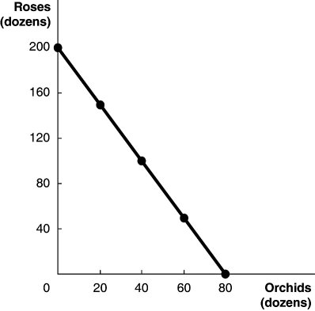

Figure 2.8 above shows the production possibilities frontier for Vidalia, a nation that produces two goods, roses and orchids.

5) Refer to Figure 2.8. The linear production possibilities frontier in the figure indicates that
A) Vidalia has a comparative disadvantage in the production of roses.
B) the trade-off between roses and orchids is constant.
C) it is progressively more expensive to produce roses.
D) it is progressively more expensive to produce orchids.
E) Vidalia has a comparative advantage in the production of orchids.

6) As incomes in Alberta fall people are drinking less craft beer and more beer produced by international brewers. Thus, an economist would consider beer produced by international brewers to be a(n)
A) unrelated good.
B) inferior good.
C) substitute good.
D) complementary good.
E) normal good.

7) The demand for lobster is higher at Christmas than in February. If the equilibrium price of lobster is lower at Christmas than in February, then
A) there are more substitutes for lobster at Christmas than there are in February.
B) consumers' tastes for lobster are greater in February than at Christmas.
C) there is a surplus of lobster at Christmas and a shortage of lobster in February.
D) the supply of lobster is lower in February than at Christmas.
E) lobsters are inferior goods at Christmas, and normal goods in February.

8) An example of a transfer payment is
A) a teacher's paycheque.
B) an Old Age Security payment.
C) a purchase of a new bridge by PEI.
D) a paycheque for a member of the Royal Canadian Air Force.
E) federal income taxes collected in Saskatchewan.

Table 4.20
 | 2019 |  | 2022
Product | Quantity | Price | Quantity | Price
Cameras | 100 | $10 | 120 | $12
Legal services | 50 | 15 | 45 | 20
Books | 200 | 40 | 210 | 45

A very simple economy produces three goods: cameras, legal services, and books. The quantities produced and their corresponding prices for 2019 and 2022 are shown in the table above.

9) Refer to Table 4.20. What is the GDP deflator in 2022 if 2019 is the base year?
A) 187 B) 100 C) 87 D) 8.7 E) 0.87

10) Except during recessions, workers in Canada are eligible for unemployment benefits for about twice as long a period of time as workers in the United States. As a result,
A) the average duration of unemployment is longer in the United States than in Canada.
B) the opportunity cost of job search in Canada is lower than in the United States.
C) cyclical unemployment is higher, on average in Canada than in the United States.
D) the unemployment rate in Canada is usually higher than in the United States.
E) frictional unemployment is higher, on average, in the United States than in Canada.

11) If the CPI changes from 125 to 120 between 2021 and 2022, how did prices change between 2021 and 2022?
A) Prices increased by 125%.
B) Prices increased by 25%.
C) Prices increased by 5%.
D) Prices decreased by 5%.
E) Prices decreased by 4%.

12) If GDP grew 3% in 2020, 2.2% in 2021, and 2.5% in 2022, what is the average annual growth rate over this period?
A) 5% B) 4% C) 2.6% D) -2.2% E) -3.1%

13) Which of the following indicates that the Canadian economy has become more stable since 1980?
A) longer recessions
B) the price level is more stable than before 1980
C) less severe fluctuations in real GDP
D) shorter expansions
E) all of the above

Table 6.2
Year | Real GDP (billions of 2007 dollars)
2019 | $1,669
2020 | 1,706
2021 | 1,748
2022 | 1,767

14) Refer to Table 6.2. Using the table above, what is the approximate growth rate of real GDP from 2020 to 2021?
A) -2.5% B) -1% C) 1% D) 2.5% E) 3.4%

15) Which of the following is a true statement about the multiplier?
A) The formula for the multiplier overstates the real world multiplier when we take into account the impact of changes in GDP on imports, inflation, and the interest rate.
B) The multiplier makes the economy less sensitive to changes in autonomous expenditure.
C) The multiplier is the ratio of the change in spending to the change in GDP.
D) The larger the MPC, the smaller the multiplier.
E) The multiplier only applies to changes in government spending.

16) If national income increases by $75 million and consumption increases by $15 million, the marginal propensity to consume is
A) 5. B) 0.80. C) 0.75. D) 0.20. E) 0.15.

17) On the long-run aggregate supply curve,
A) a decrease in the price level increases the aggregate quantity of GDP supplied.
B) a decrease in the price level increases the level of aggregate supply only at very high levels of output.
C) a decrease in the price level decreases the level of potential GDP.
D) a decrease in the price level decreases the aggregate quantity of GDP supplied.
E) a decrease in the price level has no effect on the aggregate quantity of GDP supplied.

18) If the short-run aggregate supply increases by less than the long-run aggregate supply, then, at the short-run equilibrium,
A) GDP will be below potential GDP.
B) aggregate demand will increase.
C) GDP will be above potential GDP.
D) unemployment will fall.
E) GDP will be equal to potential GDP.

19) The statement, "My iPhone is worth $300" represents money's function as
A) a store of value.
B) a medium of exchange.
C) a promoter of specialization.
D) a unit of account.
E) a standard of deferred payment.

20) The major assets on a bank's balance sheet are its
A) reserves, loans, and holdings of securities.
B) reserves, loans, and chequing account deposits.
C) chequing and savings account deposits.
D) reserves, chequing and savings account deposits.
E) loans, and chequing and savings account deposits.

21) Suppose Bill Gates deposits $20 million into his chequing account at the Royal Bank. If the required reserve ratio is 10 percent, what is the maximum change in money supply?
A) -$200 million
B) -$180 million
C) $2 million
D) $180 million
E) $200 million

22) Increases in the price level
A) increase the opportunity cost of holding money.
B) decreases the quantity of money needed as a unit of account.
C) increase the quantity of money needed for buying and selling.
D) decrease the opportunity cost of holding money.
E) decrease the quantity of money needed for buying and selling.

Figure 11.9

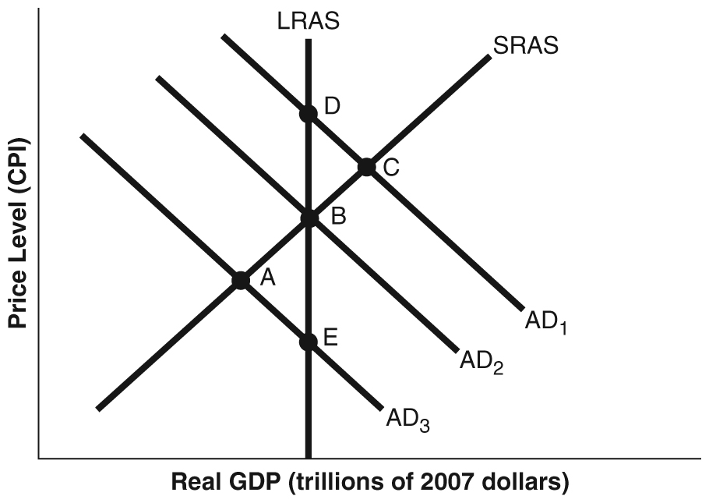

23) Refer to Figure 11.9. Suppose the economy is in a recession and no policy is pursued. Using the static AD-AS model in the figure above, this situation would be depicted as a movement from
A) C to D. B) B to A. C) C to B. D) A to B. E) A to E.

Table 11.5
Year | Potential Real GDP | Real GDP | Price Level
2022 | $1.40 trillion | $1.40 trillion | 105
2023 | 1.45 trillion | 1.42 trillion | 105.2

24) Refer to Table 11.5. Consider the hypothetical information in the table above for potential real GDP, real GDP, and the price level in 2022 and in 2023 if the Bank of Canada does not use monetary policy. If the Bank of Canada uses monetary policy successfully to keep real GDP at its potential level in 2023, which of the following will be higher than if the Bank of Canada had taken no action?
A) real GDP and the inflation rate
B) real GDP and potential GDP
C) real GDP and the unemployment rate
D) unemployment and the participation rate
E) potential GDP and the inflation rate

Figure 12.1

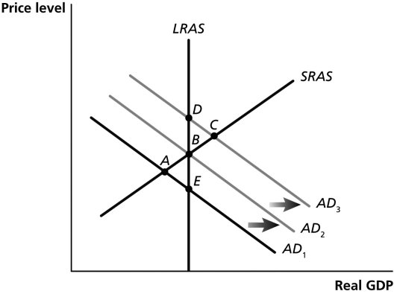

25) Refer to Figure 12.1. An increase in taxes would be depicted as a movement from ________, using the static AD-AS model in the figure above.
A) C to D B) A to B C) B to C D) B to A E) E to B

26) A decrease in which of the following would decrease the tax wedge?
A) property taxes
B) marginal tax rate
C) national debt
D) money supply
E) federal budget deficit

27) Expansionary fiscal policy
A) causes complete crowding out in the short run.
B) is never effective because of crowding out.
C) can be effective in the long run.
D) is only effective in the long run.
E) can be effective in the short run.

28) An inferior good is a good for which the quantity demanded increases as the price decreases, holding everything else constant.
A) True
B) False

29) When Jack's income increases by $5,000, he spends an additional $4,000 dollars. This implies that his marginal propensity to consume is 1.25.
A) True
B) False

30) The long-run aggregate supply curve is vertical.
A) True
B) False

1) E
2) B
3) B
4) E
5) B
6) B
7) D
8) B
9) C
10) D
11) E
12) C
13) C
14) D
15) A
16) D
17) E
18) A
19) D
20) A
21) D
22) C
23) E
24) A
25) D
26) B
27) E
28) B
29) B
30) A

